This document sets out to validate the Large Soil Moisture Probe Temperature readings and counter readings (Counter readings have already been confirmed to meet requirements).

XP1=1st Cast Probe, XP2=2nd Open Probe

Wednesday the 23rd of April 2025

Open probe is now using 10k NTC along with 10k voltage divider circuit. Overnight Temperature readings using the open test probe are shown below:

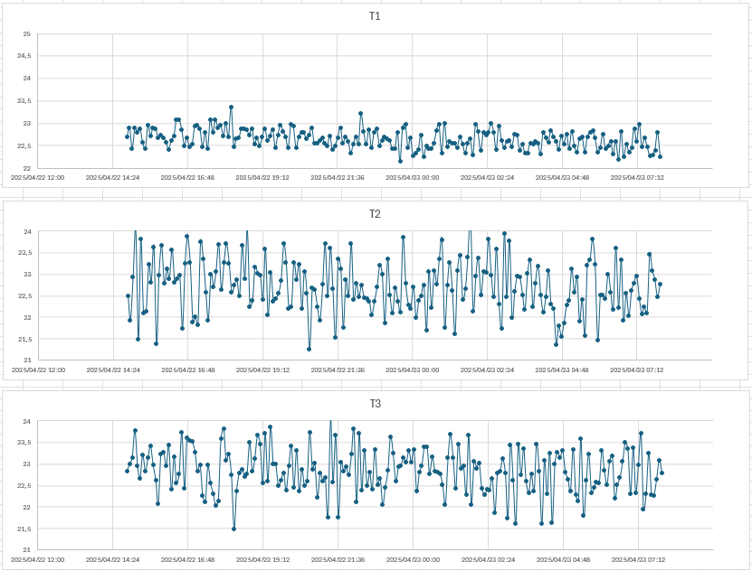

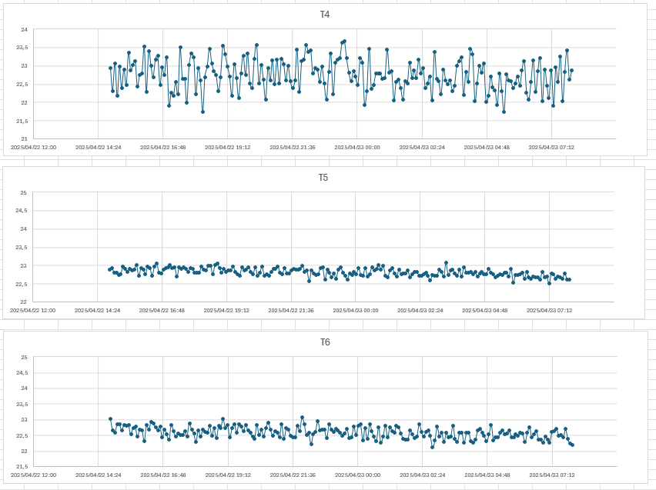



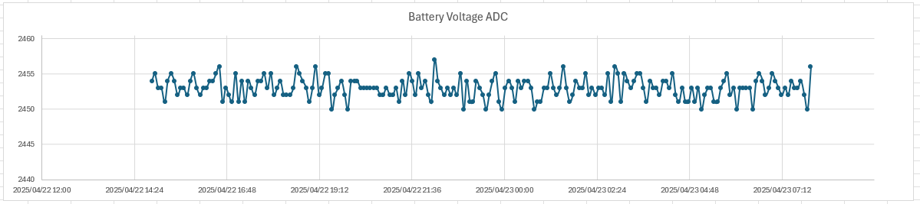

The above graphs do not meet the requirements for the temperature validation due to high noise on temperatures 2,3 and 4. Potential reasons for the noise include RS485 communication cable running through sense boards 1-4, or discrepancies in build quality of the sense rings. The RS485 cable was removed along with swapping sense ring #1 and #2 to see if a noticeable occurs. Also shown above is the battery voltage control test which shows an extremely high level of accuracy of the ADC.

The graphs below are taken from XP2(the open test probe). They show that the counter value is still within the required specs except for Counter 6. Counter 1 is excluded in this test due to space requirements on Irricheck and the inclusion of the battery voltage adc.

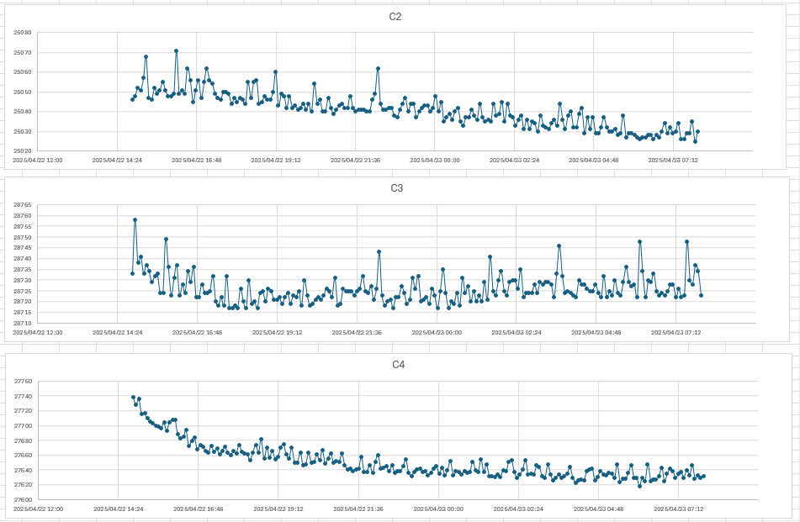

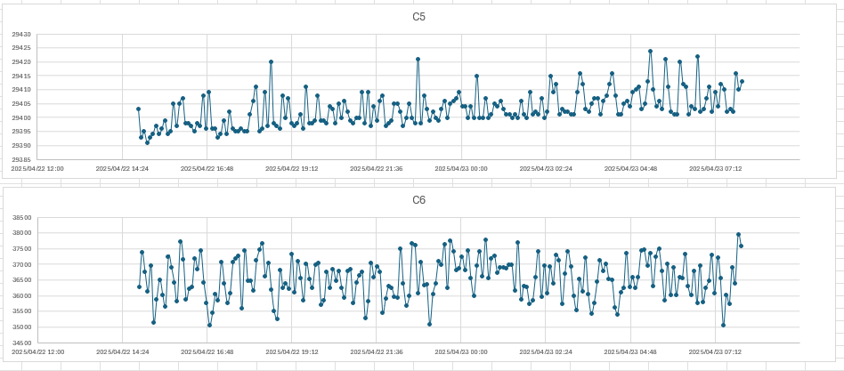

Counter validation can be confirmed using the cast test probe, with the data collected from the 22nd of April 2025 08:30 until now(23rd April 2025 08:30):

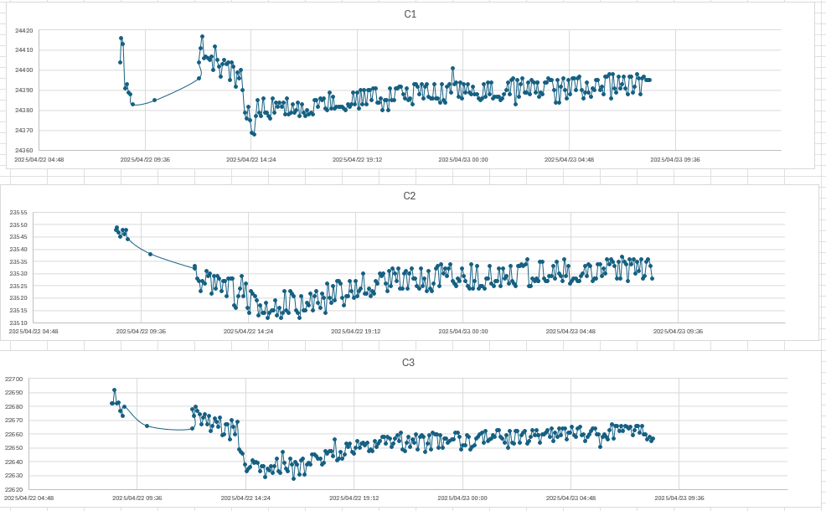

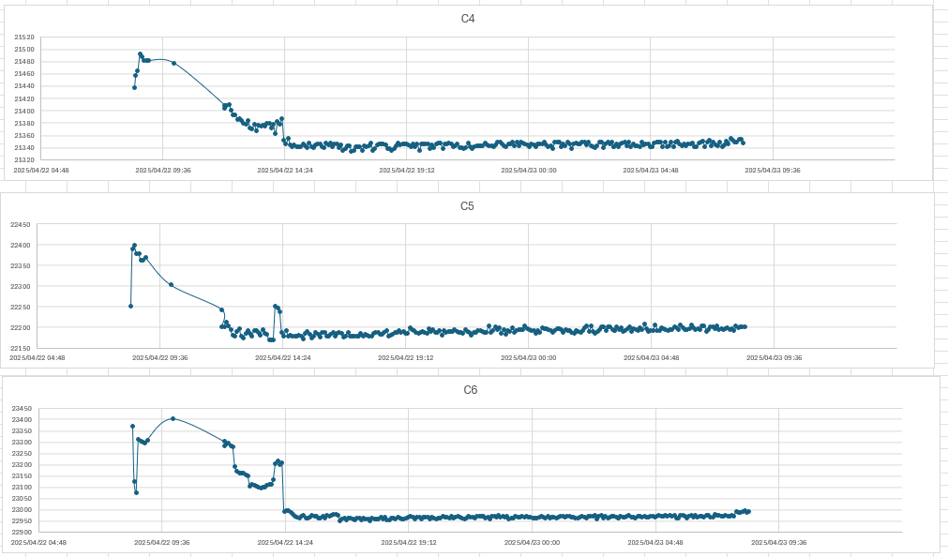

XP2(Open Probe 2) Swapped ring 5&6 at 16:22 23/04/2025.

XP2(Open Probe 2) Swapped in a rebuilt ring at position 6 at 16:33 23/04/2025

24th April 2025 XP2 (Open Probe Test)

Below are the readings taken from 23/04/2025 16:51 to 24/04/2025 08:15 of the open test probe, showing the temperature readings.

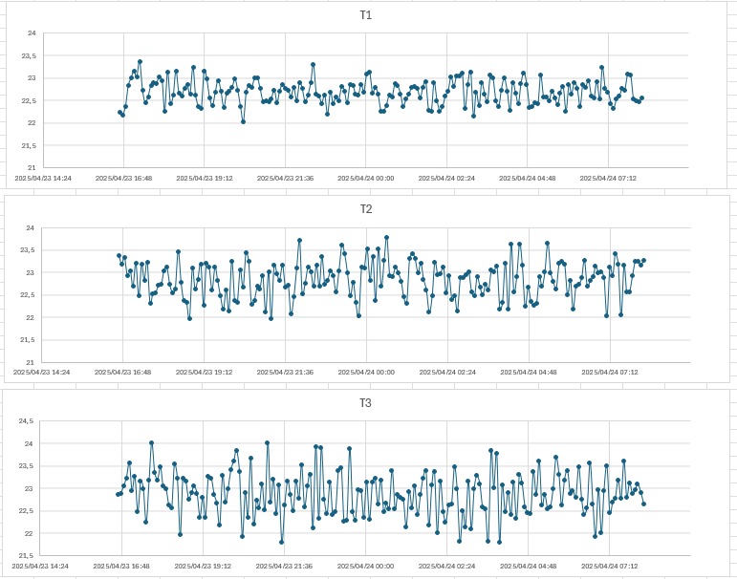

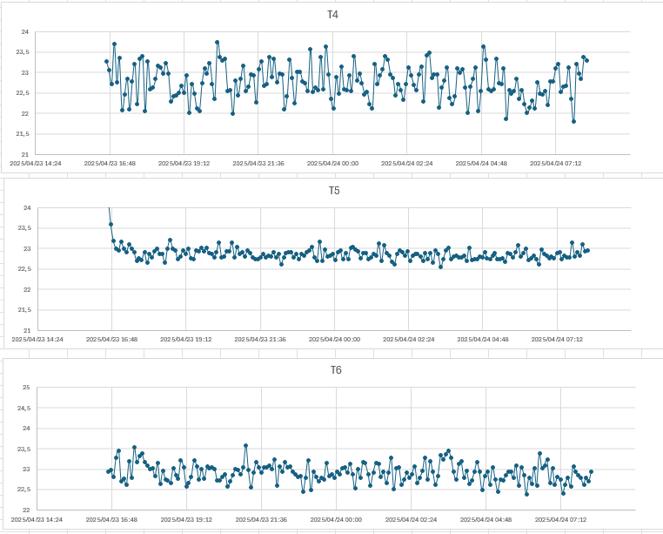

Ring 4 is swapped with the spare ring (Ring 6 from the morning readings on the 23/04/2025) to confirm if the software or hardware is causing the inaccuracy.

29/04/2025

Plot the data for the last 5 days and analyse the results.

Below are the results of the Open probe XP2, the counter values C2-C6.

Confirmation of the battery voltage divider was tested with the results in the table below, measuring was done on the voltage divider and on the appropriate pin on the MCU.

|  |  |  |
| --- | --- | --- |
| Supply voltage | Voltage on the voltage divider | Voltage on the MCU PIN |
| 4.18V | 1.903V | 1.903V |
| 4.06V | 1.852V | 1.852V |
| 3.99V | 1.818V | 1.818V |
| 3.89V | 1.767V | 1.766V |
| 3.78V | 1.716V | 1.717V |
| 3.67V | 1.665V | 1.664V |
| 3.57V | 1.620V | 1.620V |
| 3.49V | 1.578V | 1.578V |
| 3.39V | 1.528V | 1.528V |
| 3.18V | 1.426V | 1.426V |
| 3.07V | 1.376V | 1.376V |
| 3.00V | 1.342V | 1.342V |
| 2.89V | 1.292V | 1.292V |

RS485 Serial Output voltage testing of different supply voltages

|  |  |  |
| --- | --- | --- |
| Supply Voltage | Raw ADC value | MCU calculated Voltage |
| 4.21V | 2266 | 1.990V |
| 4.10V | 2204 | 1.931V |
| 3.99V | 2142 | 1.881V |
| 3.88V | 2081 | 1.828V |
| 3.78V | 2025 | 1.778V |
| 3.70V | 1987 | 1.745V |
| 3.59V | 1925 | 1.691V |
| 3.49V | 1852 | 1.627V |
| 3.28V | 1733 | 1.523V |
| 3.17V | 1674 | 1.471V |
| 3.10V | 1630 | 1.432V |
| 2.99V | 1571 | 1.380V |
| 2.89V | 1512 | 1.328V |

The output string was checked using the COM port on a laptop and the correct voltage for the battery was printed out.

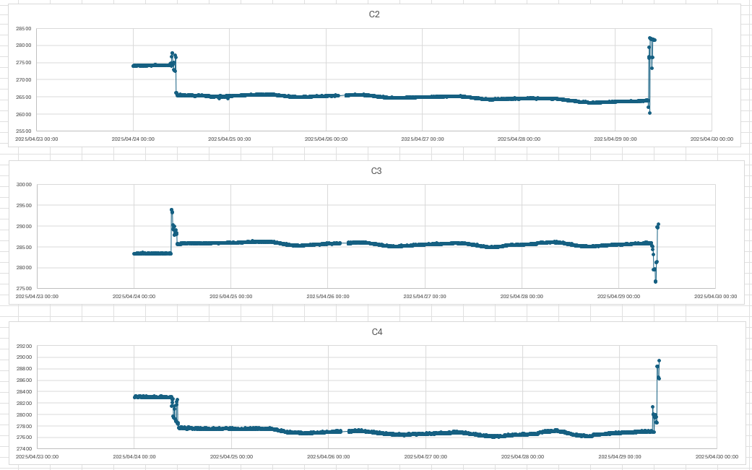The battery voltage recorded is constant due to the Roman outputting 5V to the Probe.

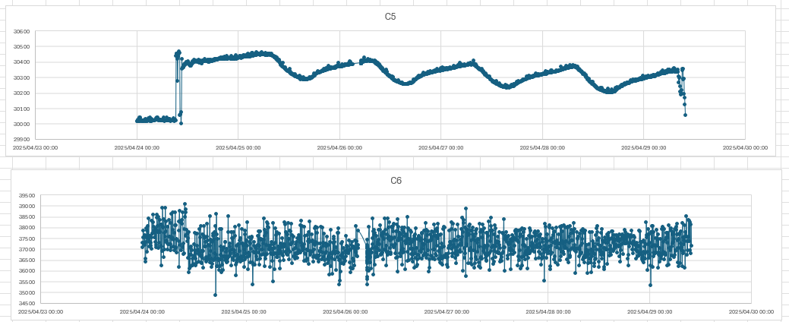

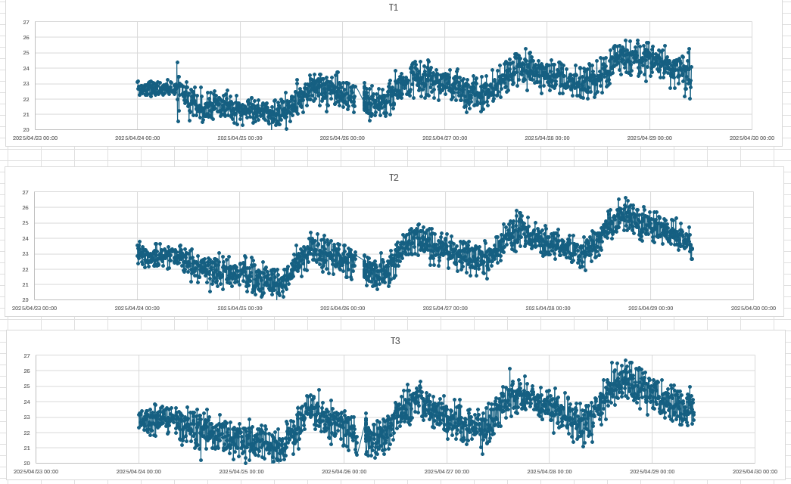Below are the results of the temperature readings for the past 5 days.

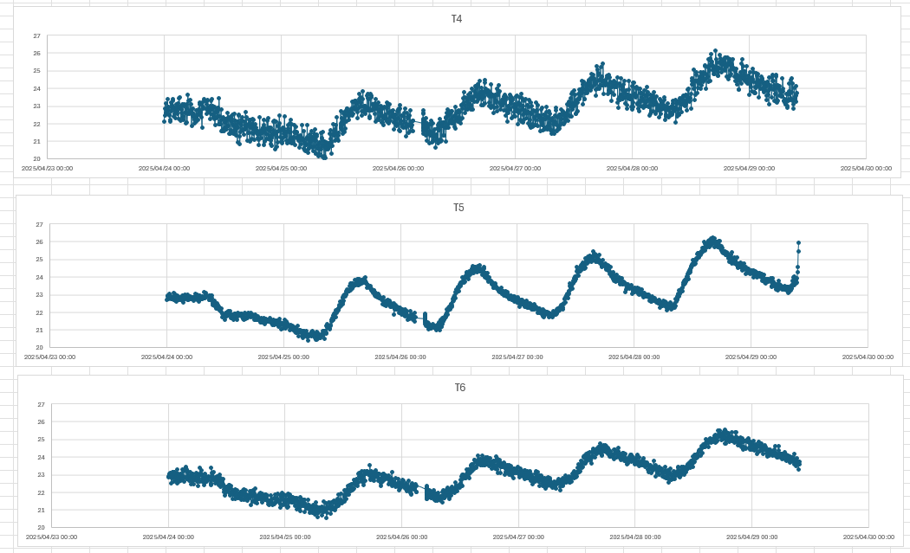

Temperature graphs with a moving average applied:

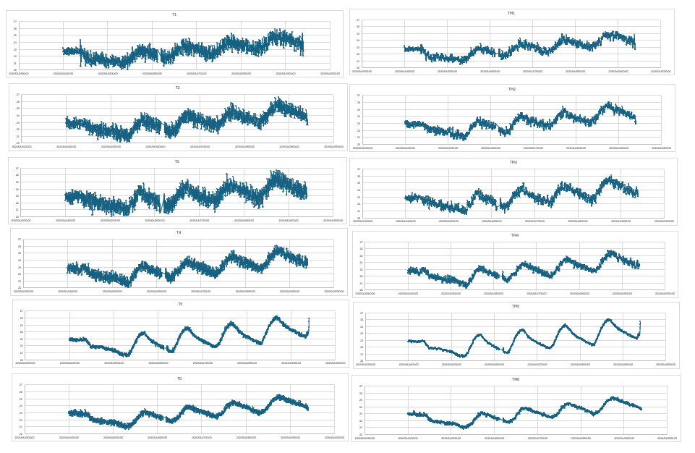

Changes to be made and tested.

Open Probe: Cables on sense rings 5 and 6 have been swapped.

01/05/2025

Below are the temperature readings from sense rings 5&6 after simply swapping the cables used between them it can be observed that the accuracy of sensor 6 improved and the accuracy of sensor 5 decreased.

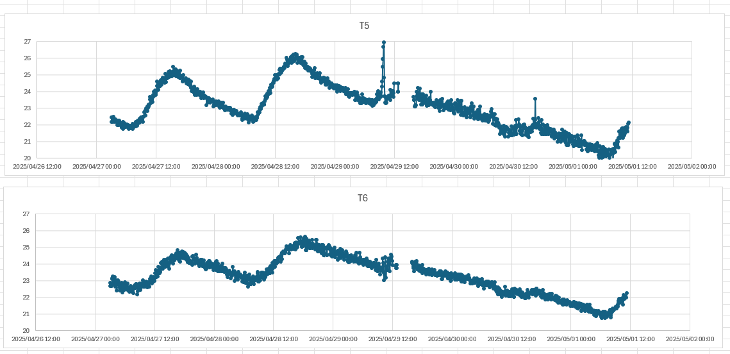

Changing all cable lengths to be the same length as the cable used for sense ring 6 that was plotted above. 01/05/2025 12:00.